ASSIGNMENT 3

|  |  |
| --- | --- |
| BATCH NUMBER | B3-3M5E |
| STUDENT NAME | BARANIE M |
| STUDENT REGISTER NUMBER | 921319104031 |

1. Create a Bucket in IBM object storage. Upload an 5 images to ibm object storage and make it public. Write html code to displaying all the 5 images. Upload a css page to the object storage and use the same page in your HTML code. Design a chatbot using IBM Watson assistant for hospital. Ex: User comes with query to know the branches for that hospital in your city. Submit the web URL of that chat bot as a assignment. Create Watson assistant service with 10 steps and use 3 conditions in it. Load that script in HTML page.

Solution:

Index.html:

<!DOCTYPE html>

<html>

<head>

<title>

Images From Cloud Object Storage

</title>

<link rel="stylesheet" href="style.css">

</head>

<body>

<h2>Images In Cloud Object Storage</h2>

<img src="https://cloud-object-storage-sk-cos-standard-0kv.s3.jp-tok.cloud-object-storage.appdomain.cloud/object-with-path-1552086.jpg"></img>

<img src="https://cloud-object-storage-sk-cos-standard-0kv.s3.jp-tok.cloud-object-storage.appdomain.cloud/obj%203.jfif"></img>

<img src="https://cloud-object-storage-sk-cos-standard-0kv.s3.jp-tok.cloud-object-storage.appdomain.cloud/obj%202.jfif"></img>

<img src="https://cloud-object-storage-sk-cos-standard-0kv.s3.jp-tok.cloud-object-storage.appdomain.cloud/download.jpg"></img>

<img src="https://cloud-object-storage-sk-cos-standard-0kv.s3.jp-tok.cloud-object-storage.appdomain.cloud/images.jpg"></img>

</body>

</html>

1. Create a Bucket in Object Storage:

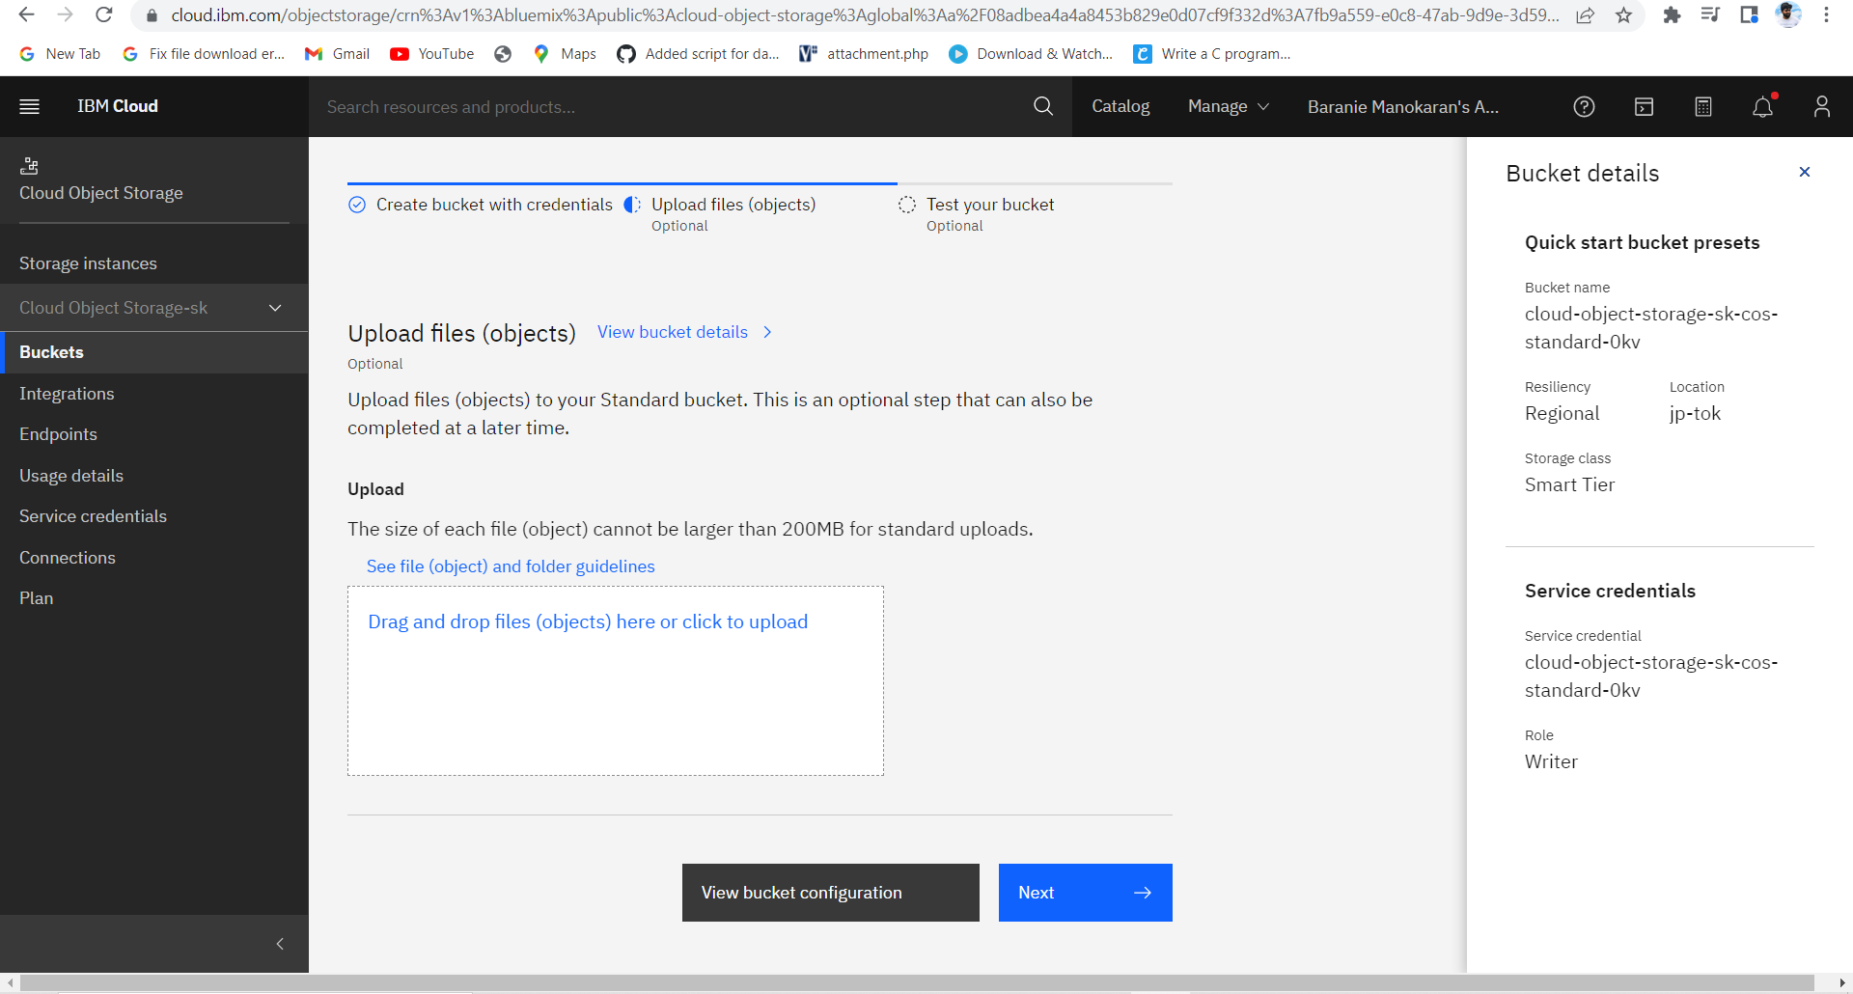

2&3. Upload an 5 images to Object storage and make it public:

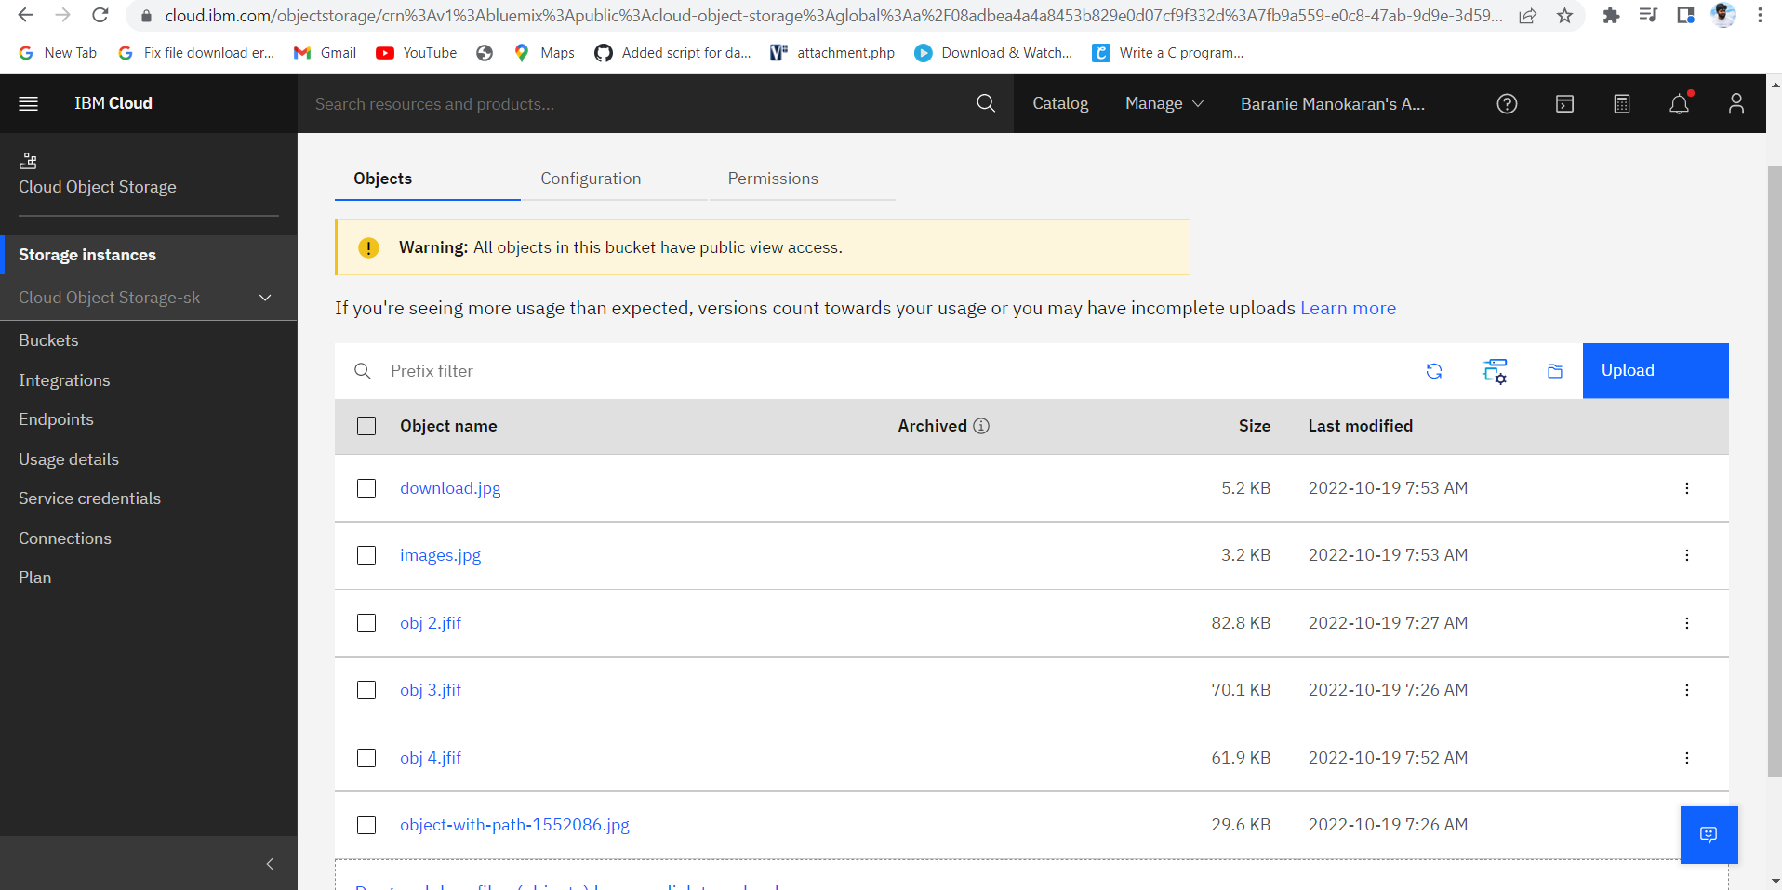

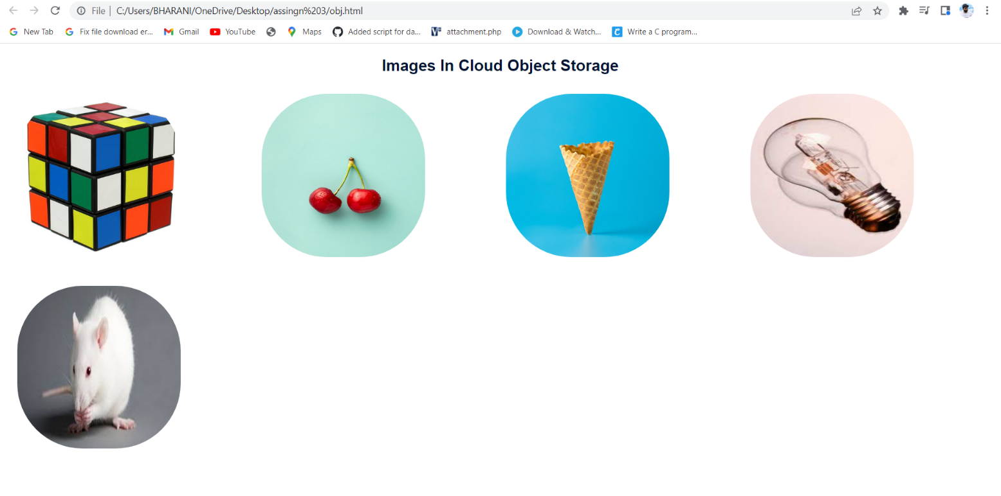

1. Create a IBM Watson for Hospital Management:

Chatbot link:

<https://web-chat.global.assistant.watson.appdomain.cloud/preview.html?backgroundImageURL=https%3A%2F%2Fau-syd.assistant.watson.cloud.ibm.com%2Fpublic%2Fimages%2Fupx-25e59597-0ccb-4797-bf68-f8930639df91%3A%3Afa5c06a0-21b6-44e8-8a57-e4239526f968&integrationID=ed3db3d7-2fb3-4898-a2b3-f079db727e0a&region=au-syd&serviceInstanceID=25e59597-0ccb-4797-bf68-f8930639df91>

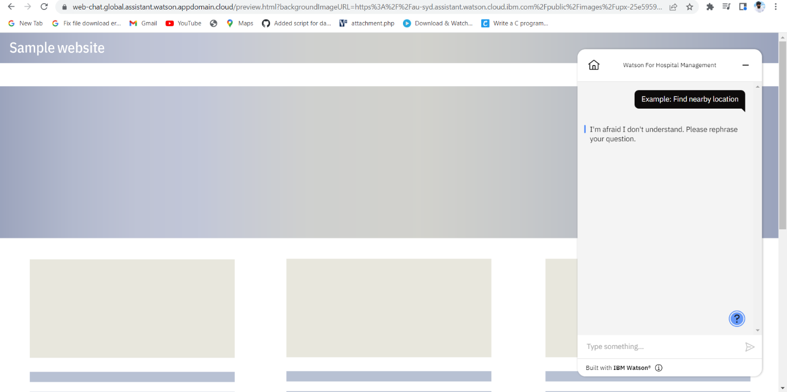

1. Create Watson Load the HTML script:

|  |
| --- |
| <!DOCTYPE html>  <html>  <head>  <title>  IBM Watson ChatBot  </title>  <link rel="stylesheet" href="style.css">  <script>  window.watsonAssistantChatOptions = {  integrationID: "ed3db3d7-2fb3-4898-a2b3-f079db727e0a", // The ID of this integration.  region: "au-syd", // The region your integration is hosted in.  serviceInstanceID: "25e59597-0ccb-4797-bf68-f8930639df91", // The ID of your service instance.  onLoad: function(instance) { instance.render(); }  };  setTimeout(function(){  const t=document.createElement('script');  t.src="https://web-chat.global.assistant.watson.appdomain.cloud/versions/" + (window.watsonAssistantChatOptions.clientVersion || 'latest') + "/WatsonAssistantChatEntry.js";  document.head.appendChild(t);  });  </script>    </head>  <body>  <h1>ChatBot Page </h1>  </body>  </html> |
|  |
|  |
|  |
|  |
|  |
|  |
|  |
|  |
|  |
|  |
|  |
|  |
|  |
|  |
|  |
|  |
|  |
|  |